

**UNIVERSITY OF PETROLEUM & ENERGY STUDIES**

**Dehradun**

**CONTINOUS INTEGRATION**

**AND**

**CONTINOUS DELIVERY**

**Experiment**

**Name: Rakshit Kapoor**

**Course: B. TECH CSE DevOps (2018-22)**

**Roll no.: R171218082**

**Sapid: 500067642**

**Experiment-6**

**Create pipeline using Jenkinsfile**

**Step-1:** Start and login to Jenkins

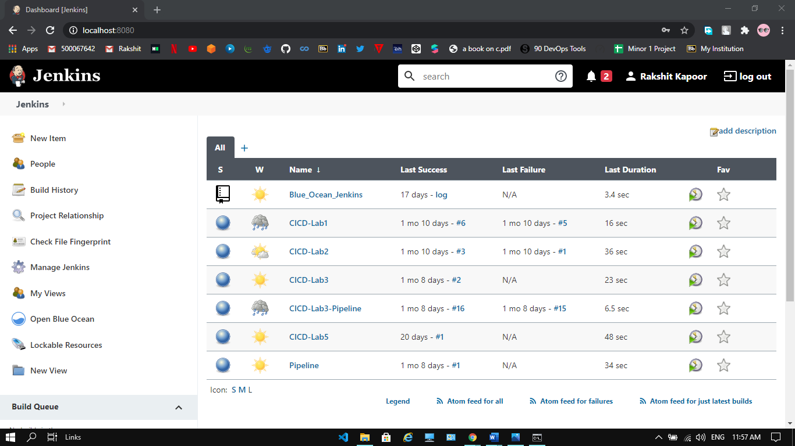

**Step-2:** Click on the new item and select pipeline project and provide the name to it and click on ok.

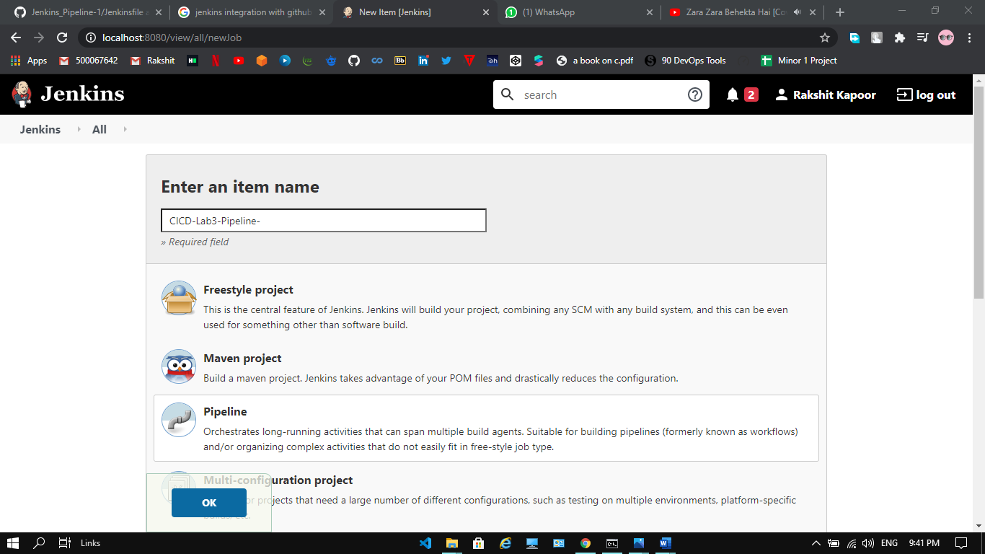

**Step-3:** provide the URL of the repository and path of Jenkinsfile. Click on Save.

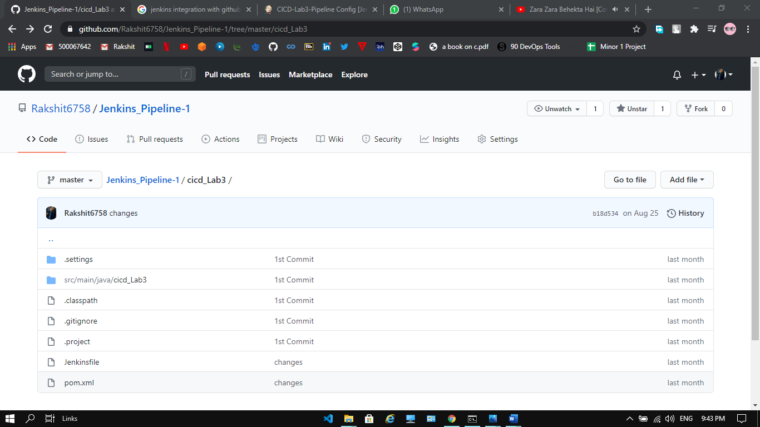

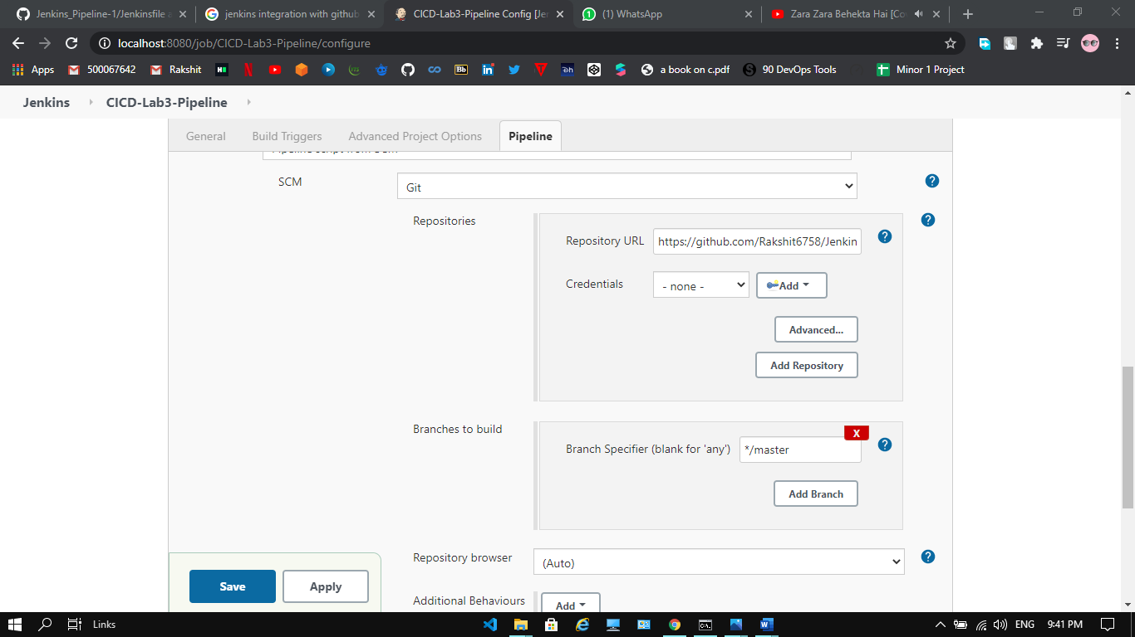

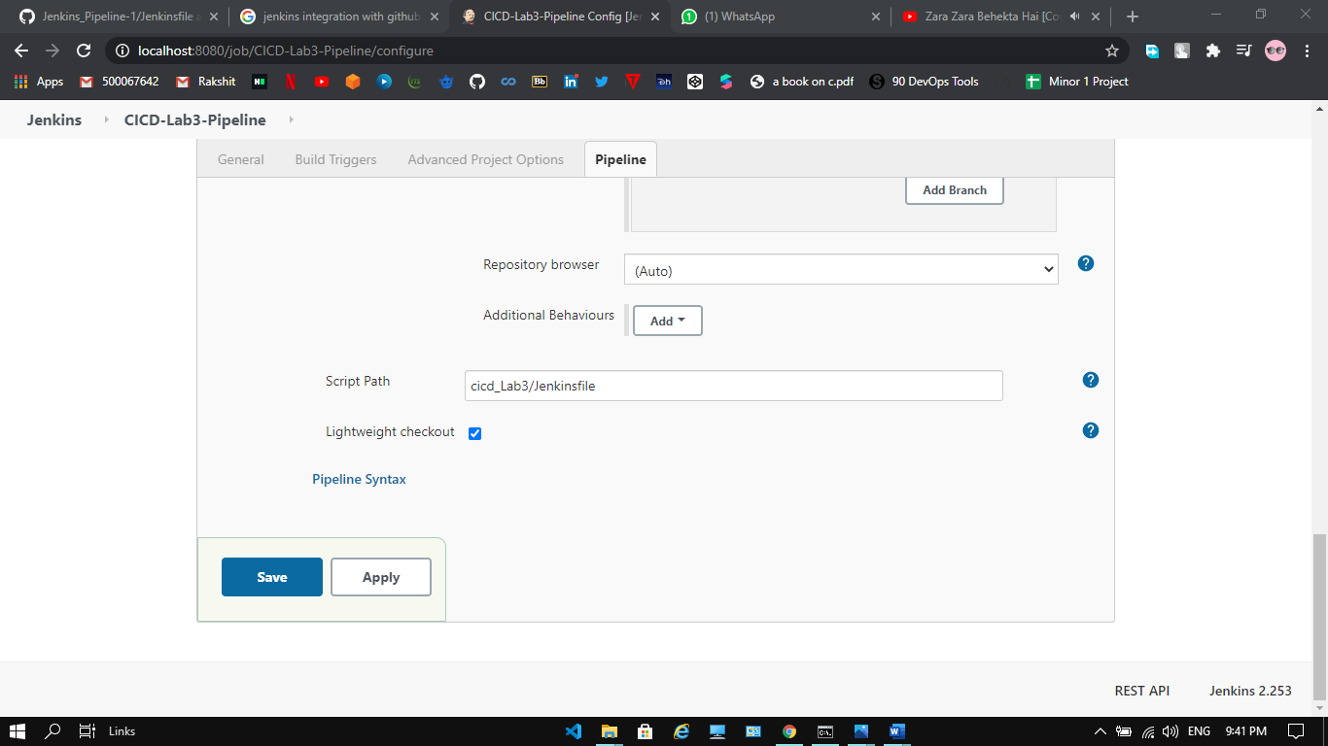

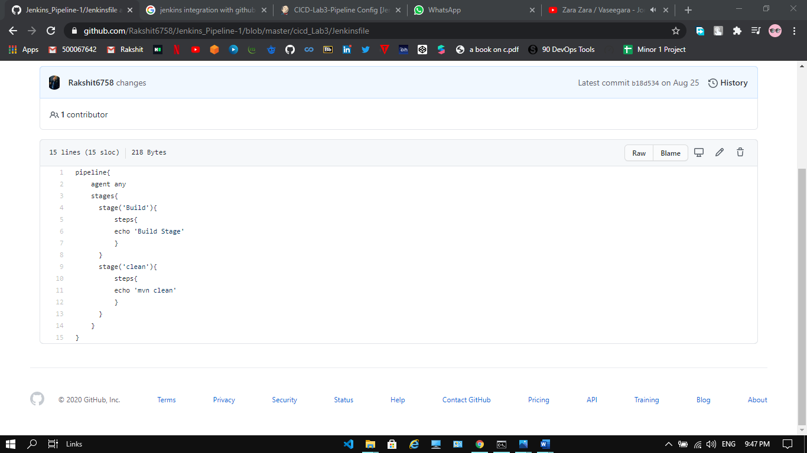

**Step-4:** Click on Build now to see the pipeline

